***DUAL BOOT EXERCISES***

**EXERCISE 2 → INSTALLATION AND CONFIGURATION OF WINDOWS 7 AND UBUNTU**

For this exercise we will need a new virtual machine. Every operating system we install must have its own partitions. The processes are exactly the same as in previous exercises.

For Windows we just have to make 1 partition to separate each operating system. The process will be the same as in previous exercises.

On the other hand, after installing Windows, we will have to change the ISO file in the virtual machine settings (in “Storage”) and install Ubuntu. Here is a scheme of the partitions we have to create for Ubuntu:

|  |  |  |  |  |
| --- | --- | --- | --- | --- |
| **PARTITION** | **MEMORY** | **TYPE** | **FILE SYSTEM** | **MOUNT POINT** |
| 1 | 1024 MB | EXT4 | PRIMARY | /boot |
| 2 | 2048 MB | SWAP AREA | LOGICAL |  |
| 3 | 15000 MB | EXT4 | LOGICAL | / |
| 4 | 13584 MB | EXT4 | LOGICAL | /home |

Once both OS are installed, we will cover the requirements of the exercise:

**PART A**

**→** Set Windows as default entry and boot after 15 seconds if the user does not select another option in the menu.

First of all we need to boot Ubuntu and enter the terminal. In it, we will write the next commands:

* **<sudo su>** and enter our password to access the root (/). This will let us modify the root files.
* **<nano /etc/default/grub>** to enter the configuration section.

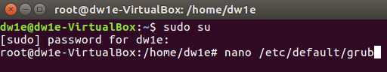

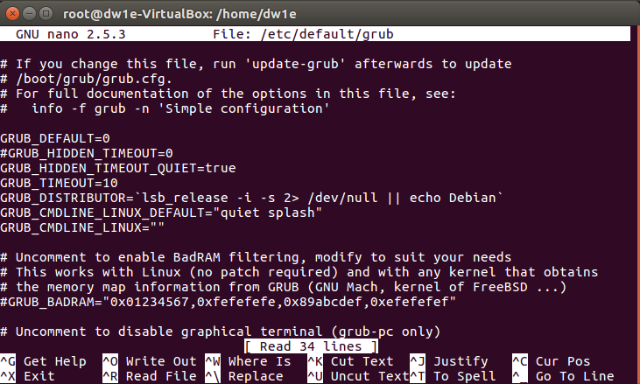

This is how it should appear for the first time.

So for this part A of the exercise, we just need to change the **GRUB_DEFAULT** value to **4** (which is Windows) and change the **GRUB_TIMEOUT** to **15**.

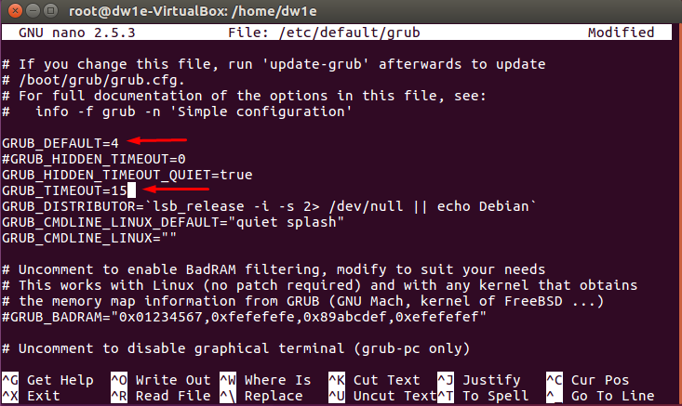

To confirm these configurations we have to press CTRL + X, then press Y and Enter to confirm everything.

 → (Y)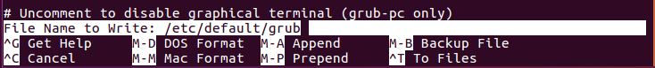 → (Enter)

This will boot Windows automatically after a 15 seconds countdown.

Finally, we will have to update the grub with **<update-grub>**.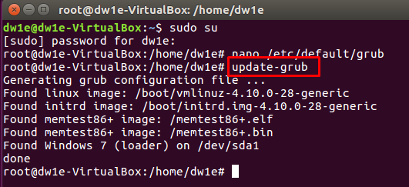

Then we can reboot our machine by typing **<exit>** (to leave the root) and **<reboot>**.

After it, we should see the bootloader menu with every option. In this case, the highlighted one should be Windows, and the countdown should appear down below.

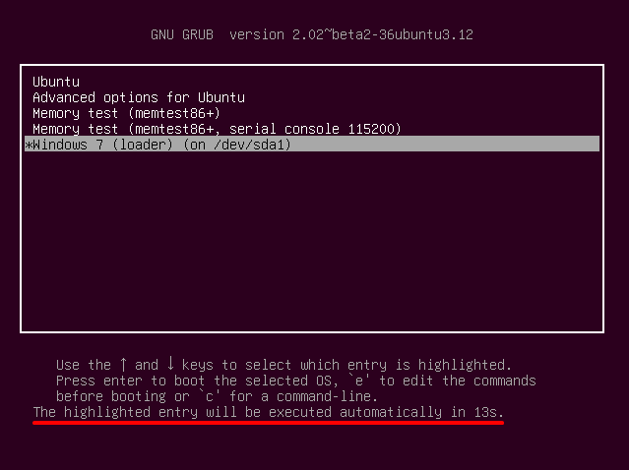

**PART B**

→ Boot Ubuntu without displaying the menu after showing a 10 seconds countdown

\*\**WARNING*: For the rest of the parts of this exercise we will have to do one more step after the **<update-grub>** command: We will have to type **<nano /boot/grub/grub.cfg>** to change the grub.cfg file. We need to go straight down until we find an “if” sentence and comment it using “#” at the beginning of each of its lines:

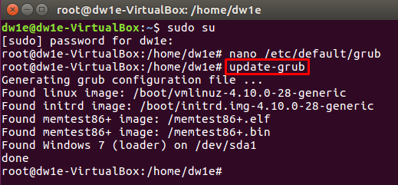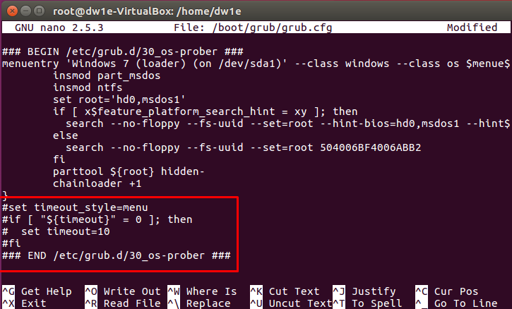

For this part B, we have to add some more things in the configuration section. We will type again:

* **<sudo su>** and enter our password to access the root (/). This will let us modify the root files.
* **<nano /etc/default/grub>** to enter the configuration section.

Now we will have to erase the **GRUB_HIDDEN_TIMEOUT** and **GRUB_HIDDEN_TIMEOUT_QUIET** lines and write “**GRUB_TIMEOUT_STYLE=countdown**” so that Ubuntu is set as default, with a 10 seconds countdown and without manu (a blank screen will appear, only with the countdown).

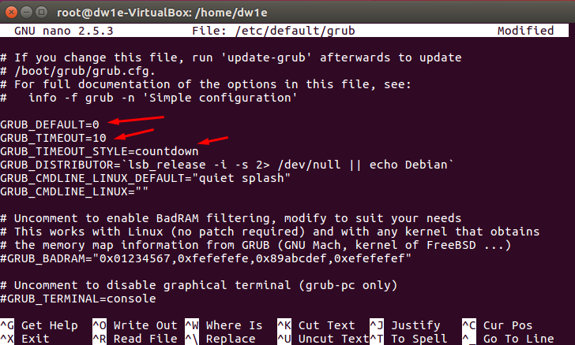

* CTRL + X , Y, Enter
* **<update-grub>**
* **<nano /boot/grub/grub.cfg>** → comment the “if” sentence using “#”
* CTRL + X , Y, Enter
* **<exit>**
* **<reboot>**

**ANOTHER WAY TO DO IT:

**→ GRUB_DEFAULT=0**

**→ GRUB_HIDDEN_TIMEOUT=10**

**→ GRUB_HIDDEN_TIMEOUT_QUIET=false**

**→ GRUB_TIMEOUT=10**

After these configurations and rebooting, we should see the 10 seconds countdown in a blank screen which will boot Ubuntu when the countdown finishes:

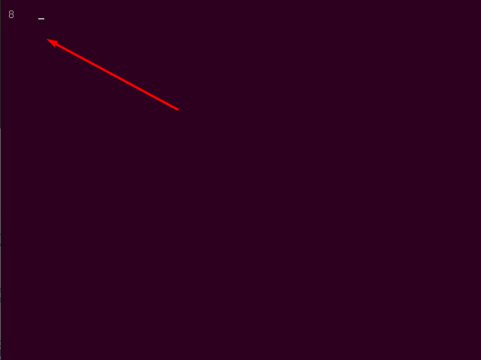

**PART C**

→ Boot Ubuntu without displaying the menu.

For this part C, we have to change two command lines from the previous configuration. We will type again:

* **<sudo su>** and enter our password to access the root (/). This will let us modify the root files.
* **<nano /etc/default/grub>** to enter the configuration section.

Now we will change the value in **GRUB_TIMEMOUT_STYLE** from **countdown** to **hidden** and change the **GRUB_TIMEOUT** value from **10** to **0** seconds.

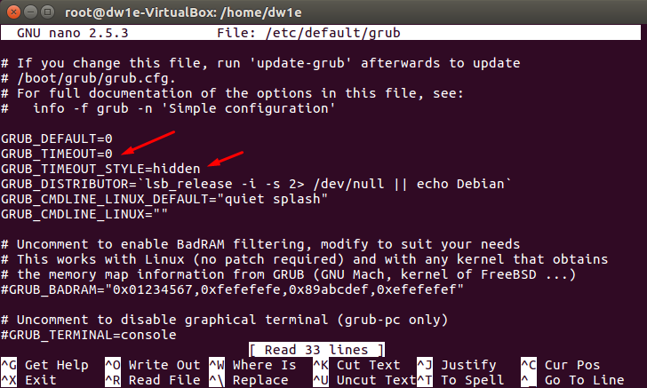

* CTRL + X , Y, Enter
* **<update-grub>**
* **<nano /boot/grub/grub.cfg>** → comment the “if” sentence using “#”
* CTRL + X , Y, Enter
* **<exit>**
* **<reboot>**

**ANOTHER WAY TO DO IT:

**→ GRUB_DEFAULT=0**

**→ GRUB_HIDDEN_TIMEOUT=0**

**→ GRUB_HIDDEN_TIMEOUT_QUIET=true**

**→ GRUB_TIMEOUT=0**

What we should see now is a blank screen (without countdown) for a brief moment. When it disappears, Ubuntu should boot automatically.



**PART D**

→ Boot Windows without displaying the menu.

Finally, for this part D, we have to change one more command line from the previous configuration. We will type again:

* **<sudo su>** and enter our password to access the root (/). This will let us modify the root files.
* **<nano /etc/default/grub>** to enter the configuration section.

Here we just have to change the **GRUB_DEFAULT** value to **4** again, in order to set Windows as default OS.

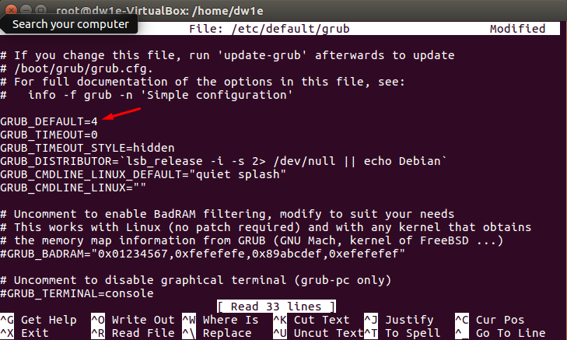

* CTRL + X , Y, Enter
* **<update-grub>**
* **<nano /boot/grub/grub.cfg>** → comment the “if” sentence using “#”
* CTRL + X , Y, Enter
* **<exit>**
* **<reboot>**

**ANOTHER WAY TO DO IT:

**→ GRUB_DEFAULT=4**

**→ GRUB_HIDDEN_TIMEOUT=0**

**→ GRUB_HIDDEN_TIMEOUT_QUIET=true**

**→ GRUB_TIMEOUT=0**

As in part C, we should see a blank screen (without the countdown) for a brief moment. After this time, Windows should boot automatically.

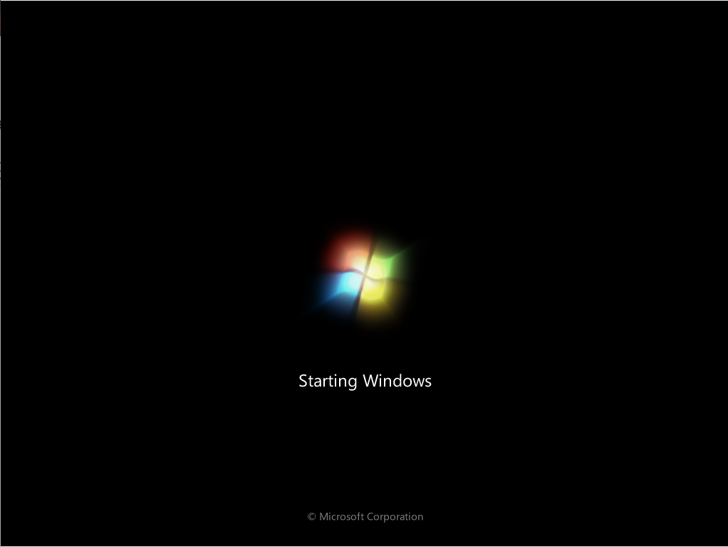

**\*\***We must mention that in both, part C and part D, if we are fast enough to press “Esc” while the blank screen is present, we will be able to open the menu.

At this point, we will have finished our work!

**ALFREDO PUERTA GALLEGO DW1E**